

**Final Project**

**Database Design – people Operations Database of a Small Businesses(HR database)**

**Final Project for Advanced Database Management System |**

**GROUP RED| ISM6218.004F22.95919**

**Advanced Database Management**

**Team Members**

Abbas Shaik

Srikar Pusuluri

Sai Shiva Ram Reddy Vudumula

Nithin Reddy Muduganti

Dharma Rakshak Tadi

# 

# Summary of Contents

|  |  |  |
| --- | --- | --- |
| **Serial No.** | **Title** | **Page No.** |
| 1. | Responsibilities | **3** |
| 2. | Entities to be Tracked | **4** |
| 3. | Entities with Attributes Nested | **5** |
| 5. | Data Dictionary | **6** |
| 6. | Entity Relationship Documentation (ERD) | **8** |
| 7. | Table Views | **7** |
| 8. | Data Synthesis | **11** |
| 9. | Data Visualization | **11** |
| 9. | Data Integrity | **9** |
| 10. | Test Queries/Stored Proc | **10** |
| 11. | Performance Tuning | **14** |
| 13. | DBA Scripts | **16** |

## **Responsibilities**

|  |  |  |  |
| --- | --- | --- | --- |
| **Topic Area**  **Database Design**  **Query Writing** | **Description**  This part should include a logical database design (for the relational model), using normalization to control redundancy and integrity constraints for data quality  This part is another chance to write SQL queries, explore transactions, and even do some database programming for stored procedures. | **Group Member**  Sai Shiva Ram Reddy Vudumula/ Abbas Shaik  Abbas Shaik / Srikar Pusuluri / Sai Shiva Ram Reddy Vudumula | **Weight**  28  24 |
| **Data visualization**  **Other Topics** | In this section, you can capitalize and extend your prior experiments visualization, optimizer modes, graphs, data modelling and any other techniques you want to further explore.  Here you are free to explore any other topics of interest. Suggestions include: DBA scripts, database security, interface design, data mining, and NoSQL databases | Sai Shiva Ram Reddy Vudumula  Nithin Reddy Muduganti/  Srikar Pusuluri  Abbas Shaik Srikar Pusuluri  Nithin Reddy Muduganti  Dharma Rakshak Tadi | 25  23 |

**Entities identified to be tracked**

| **Table** | **Rows** |
| --- | --- |
| Workforce2 | 40 |
| Nominee2 | 30 |
| Division2 | 11 |
| Position2 | 11 |
| Site2 | 7 |
| Country2 | 25 |
| Area2 | 4 |

**Entities with Attributes nested**

**❖** workforce2**:**

* 1. **worker_id first_name**
  2. **last_name**
  3. **email**
  4. **phone_number**
  5. **hire_date**
  6. **position_id**
  7. **salary**
  8. **manager_id**
  9. **division_id**
  10. **FOREIGN KEY**

**FOREIGN KEY (division_id) REFERENCES division2 (division_id) ON DELETE CASCADE,**

* **Position2:**

1. **position_id,**
2. **position_title,**
3. **position_min_salary,**
4. **position_max_salary**

* nominee2:

1. **nominee_id,**
2. **first_name,**
3. **last_name,relation,**
4. **worker_id**

* division2:

1. **division_id,**
2. **division_name,**
3. **location_id**

* area2:

1. **area_id,**
2. **area_name**

* country:

1. **(country_id,**
2. **country_name,**
3. **area_id)**

* site

1. **location_id**
2. **street_address,**
3. **pin_code,**
4. **city,**
5. **state_province,**
6. **country_id**

**DATA DICTIONARY**

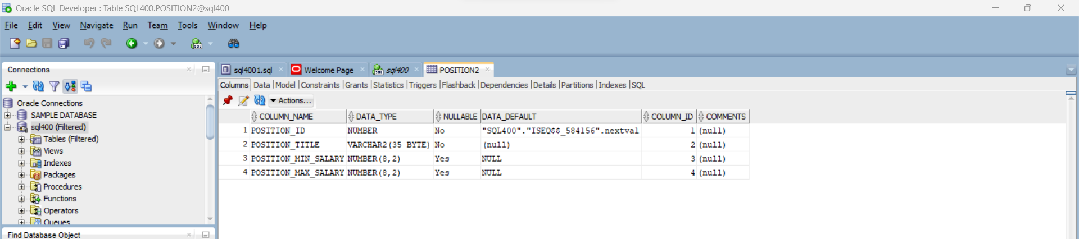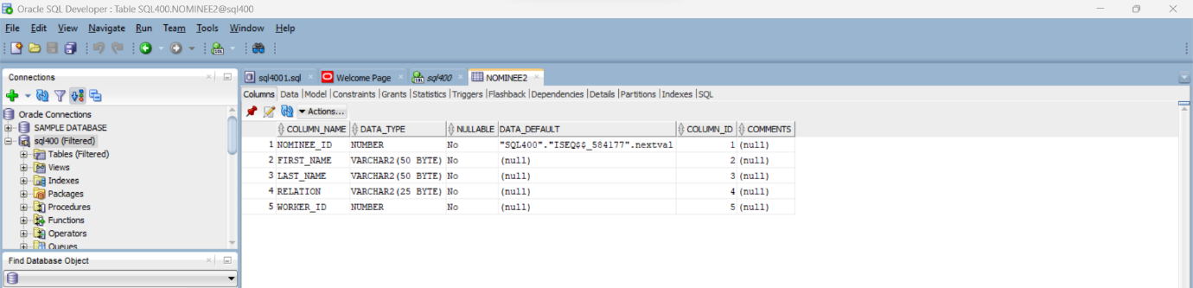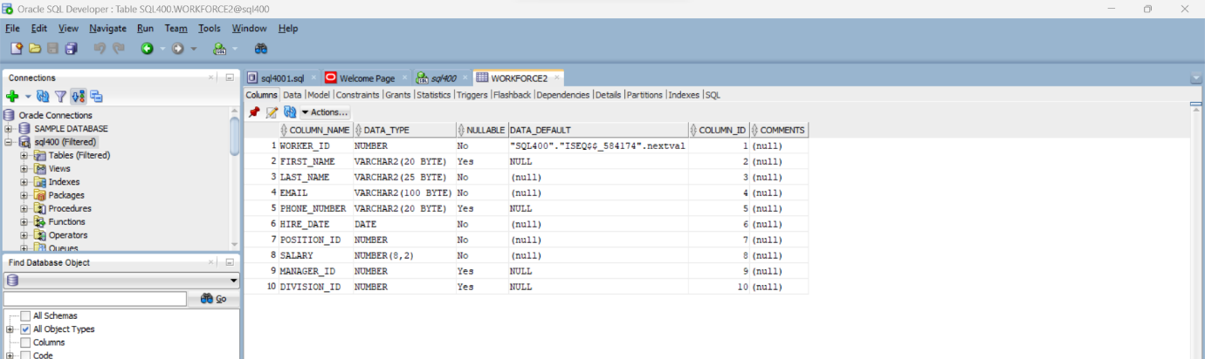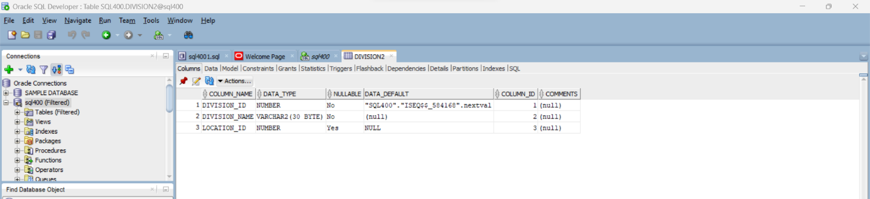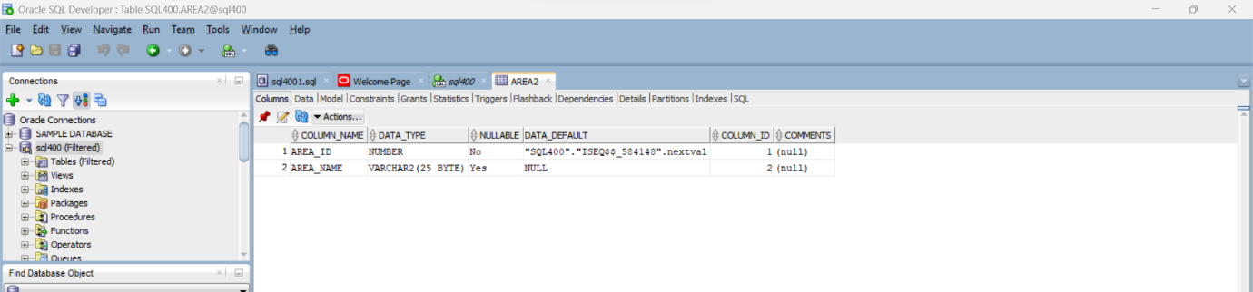

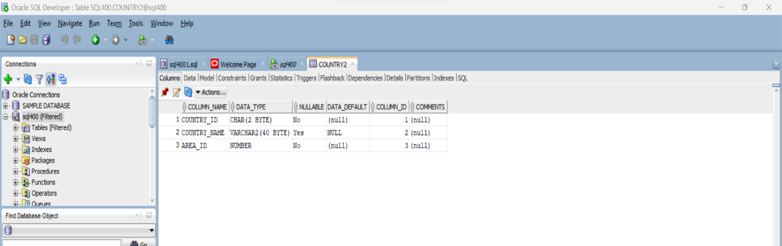

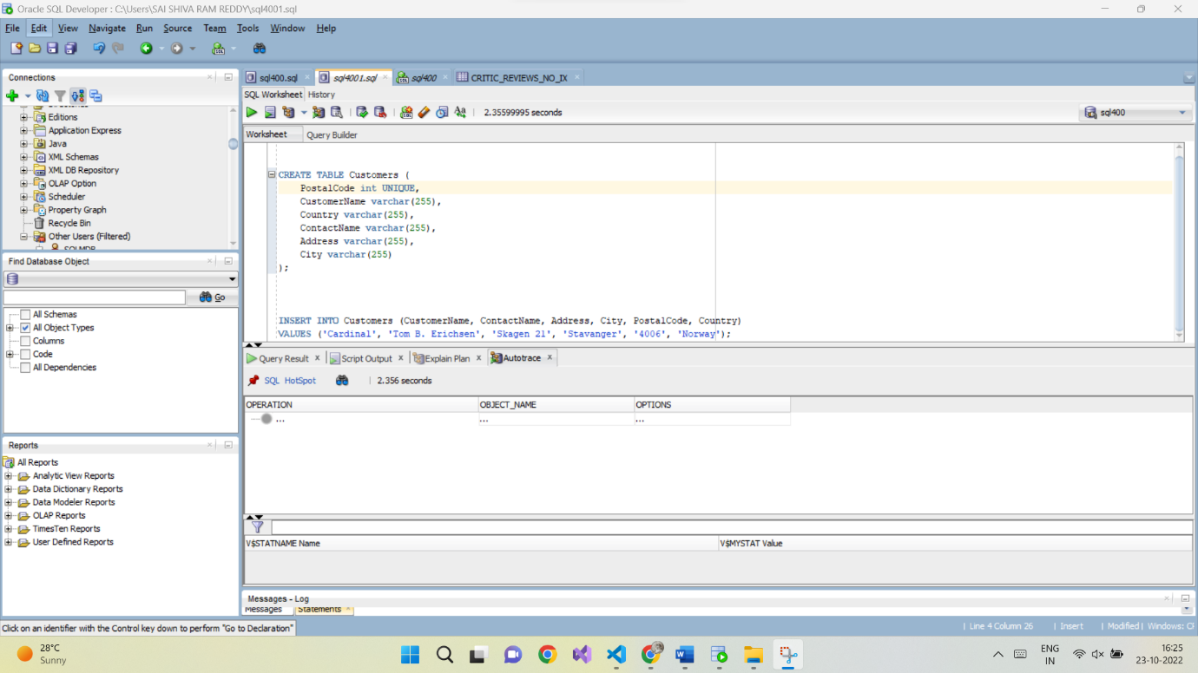

**Entity Relationship Diagram representing Database Design**

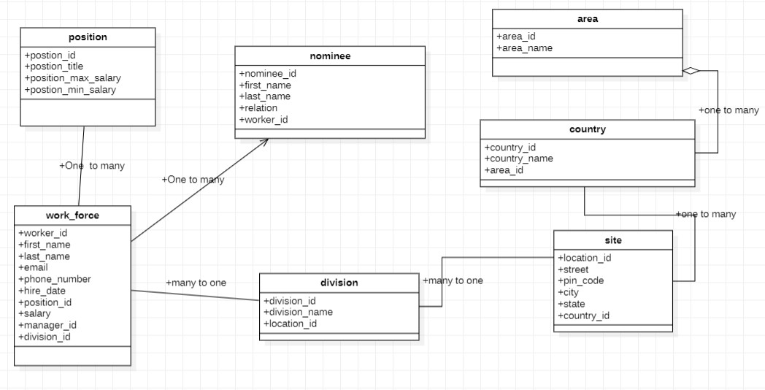

**Data explanation:**

The people operation database has seven tables:

1. The workforce table stores the data of employees.
2. The position table stores the job data including job title and salary range.
3. The division table stores department data.
4. The nominee table stores the employee’s dependents.
5. The site table stores the location of the departments of the company.
6. The country table stores the data of countries where the company is doing business.
7. The area table stores the data of regions such as Asia, Europe, America, and the Middle East and Africa. The countries are grouped into regions

**Data Synthesis:**

The data for the project has been synthesized using a combination of an online tool named Mockaroo and Microsoft Excel. Some of the prominent functions that were used in Excel include

* INDEX
* CONCAT
* RAND

|  |  |
| --- | --- |
| Workforce2 | 40 |
| Nominee2 | 30 |
| Division2 | 11 |
| Position2 | 11 |
| Site2 | 7 |
| Country2 | 25 |
| Area2 | 4 |

* RANDBETWEEN

**Data Integrity**

Data Integrity refers to the consistency and maintenance of the data through the life cycle of the database. In a database, data integrity can be ensured through the implementation of Integrity Constraints in a table. Integrity constraints help apply business rules to the database tables. The constraints can either be at a column level or a table level. Some of the most common constraints are:

* NOT NULL – Prevents a column from having a NULL value.

* PRIMARY KEY – Uniquely identifies each row or record in table.

* FOREIGN KEY – Uniquely identifies a column that references a PRIMARY KEY in another table.

* UNIQUE – Prevents a column from having duplicate values.

* CHECK – Checks for values that satisfy a specific condition as defined by the user.

Listed below are the constraints that were created for our database development project along with their purpose:

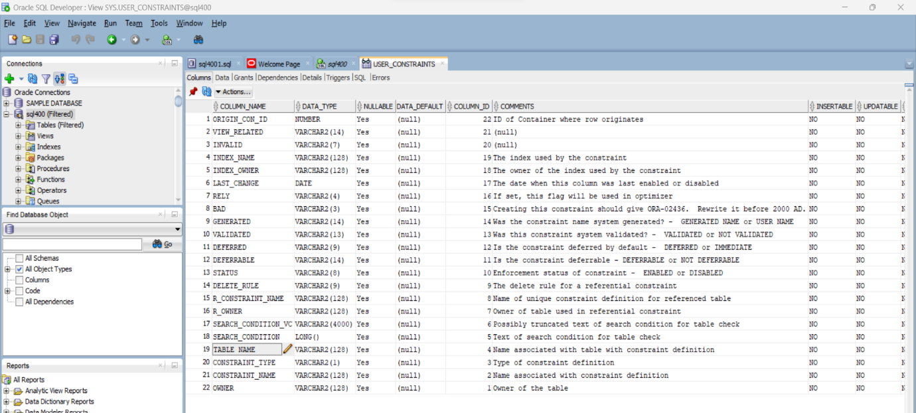

**Data constraints:**

SQL constraints are used to specify rules for the data in a table.

Constraints are used to limit the type of data that can go into a table. This ensures the accuracy and reliability of the data in the table. If there is any violation between the constraint and the data action, the action is aborted.

Constraints can be column level or table level. Column level constraints apply to a column, and table level constraints apply to the whole table.

**Country2 table:**

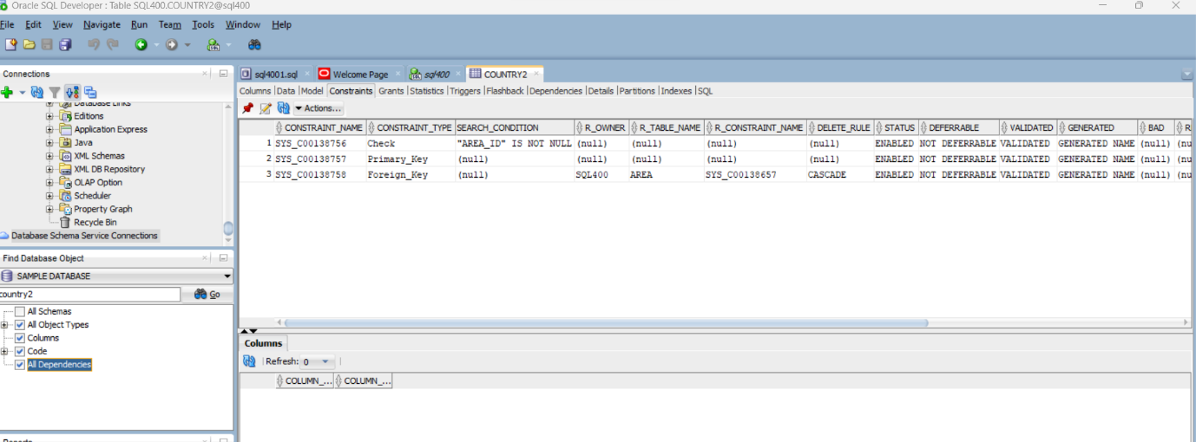

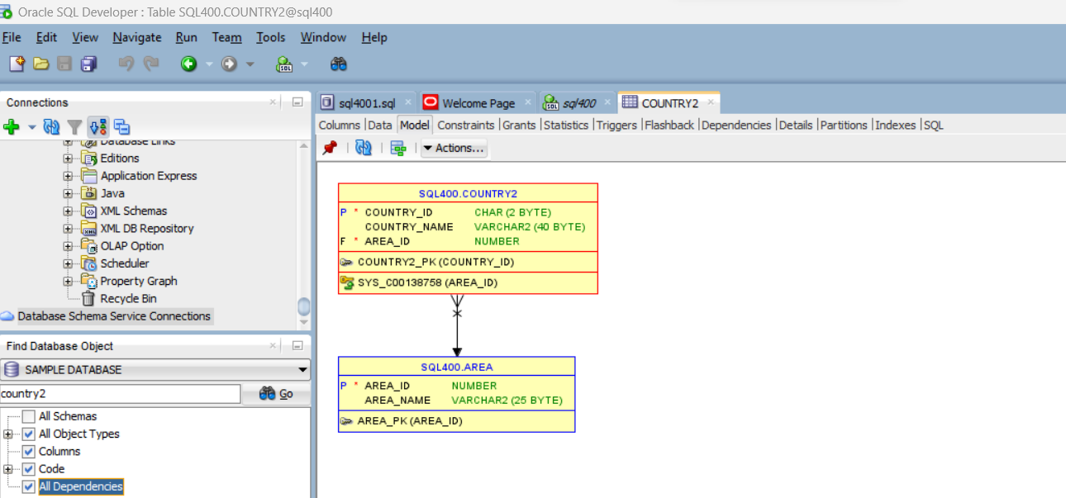

**Workforce2 :**

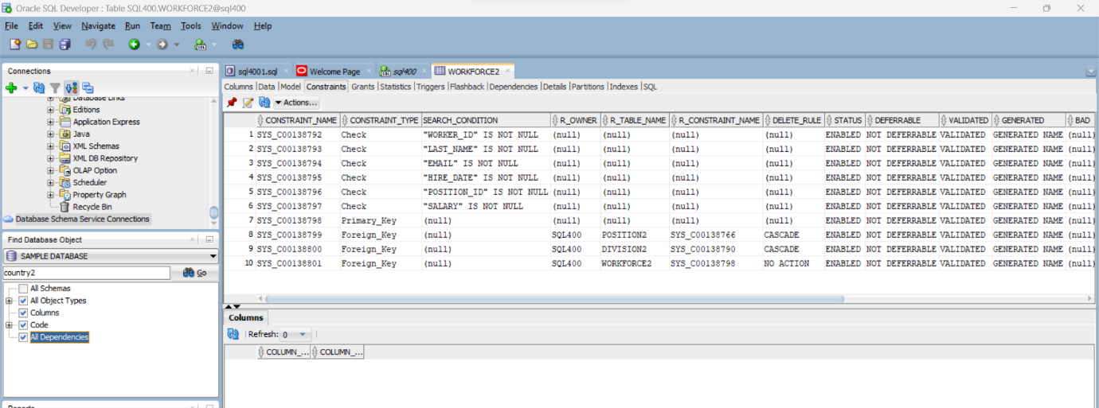

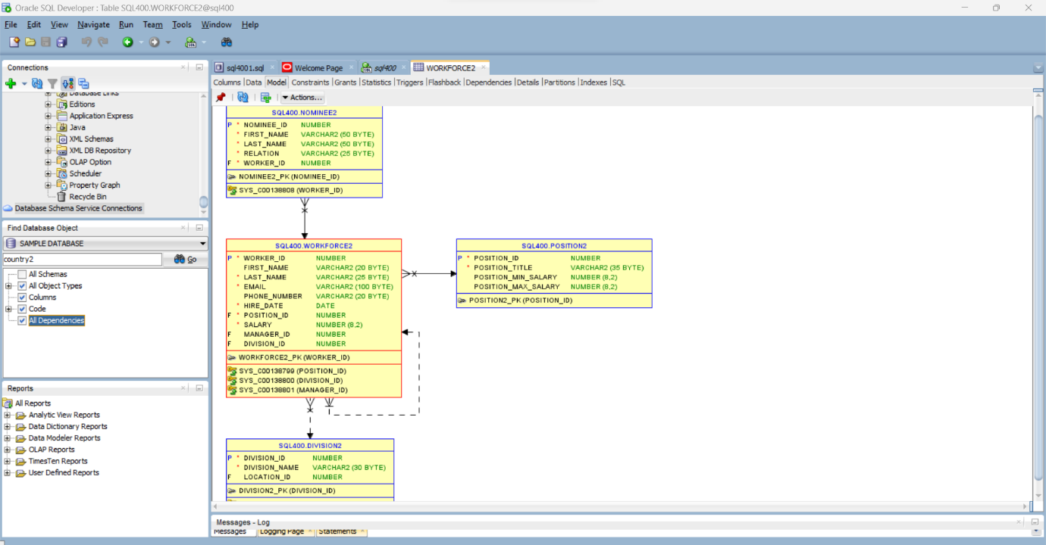

**Site2:**

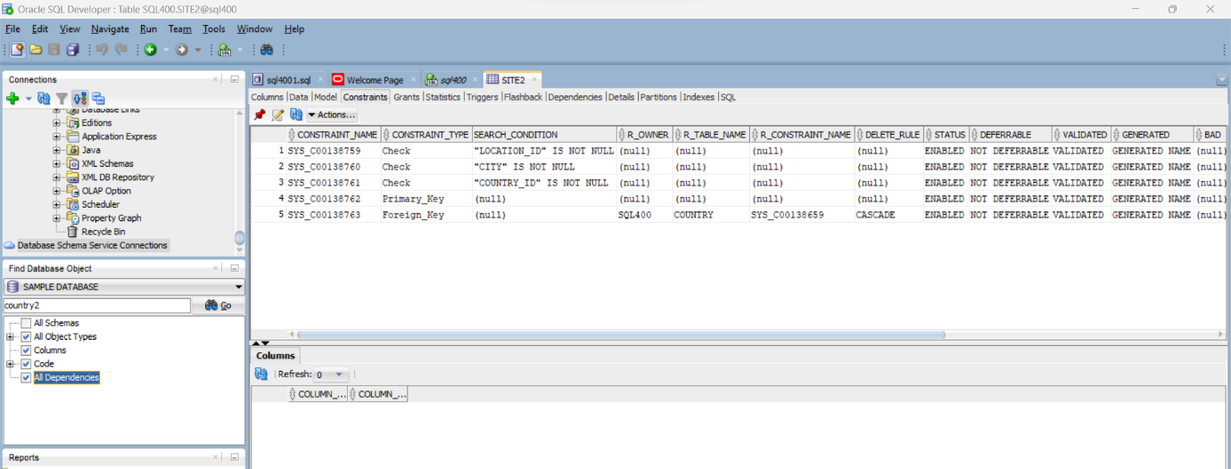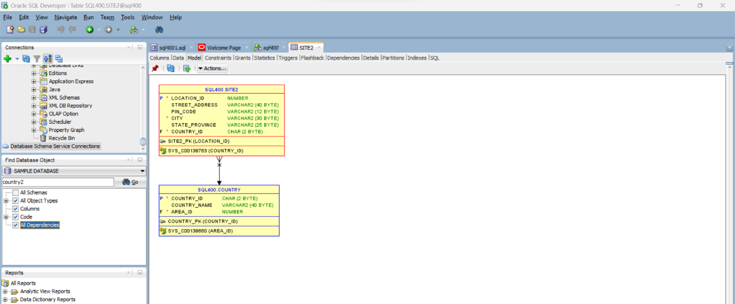

**Nominee2:**

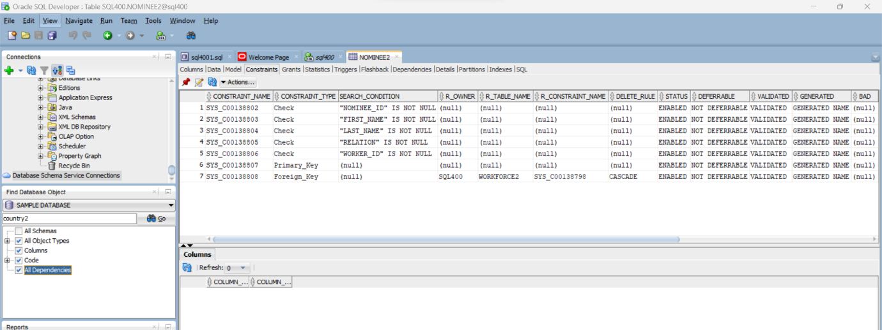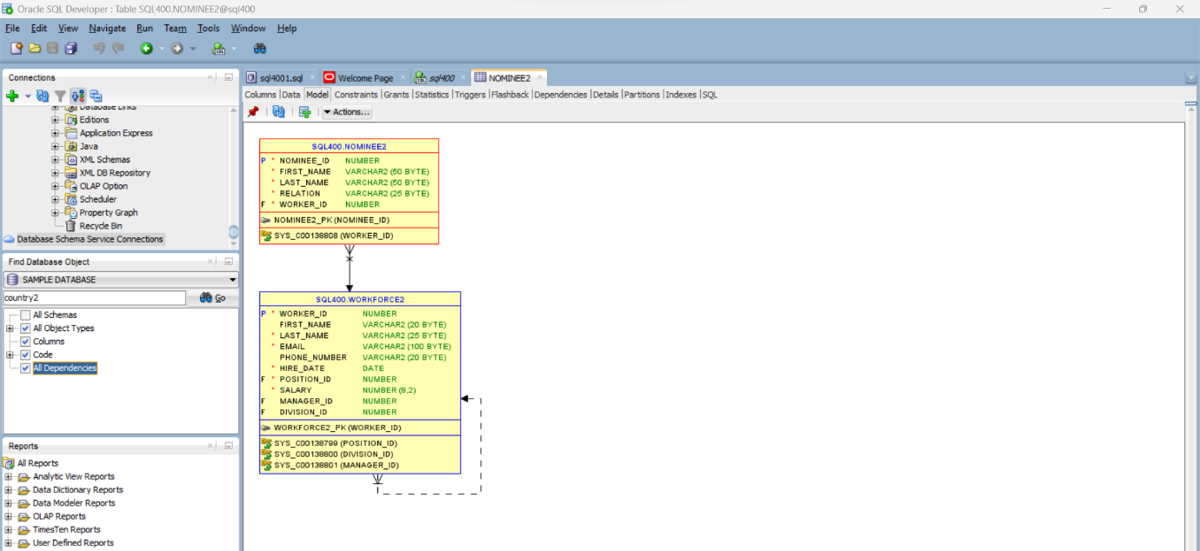

**Area2:**

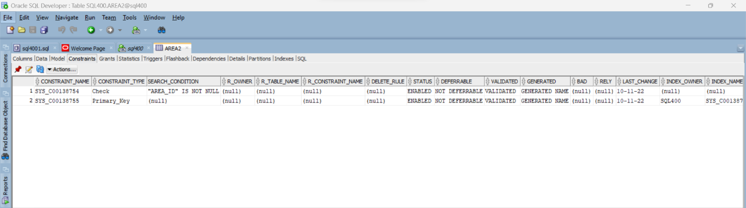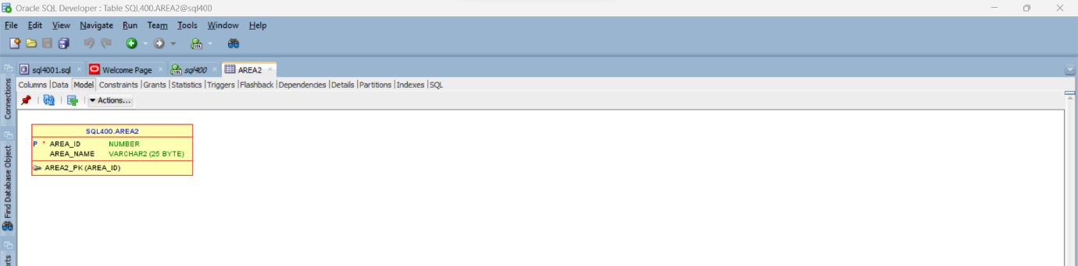

**Position2:**

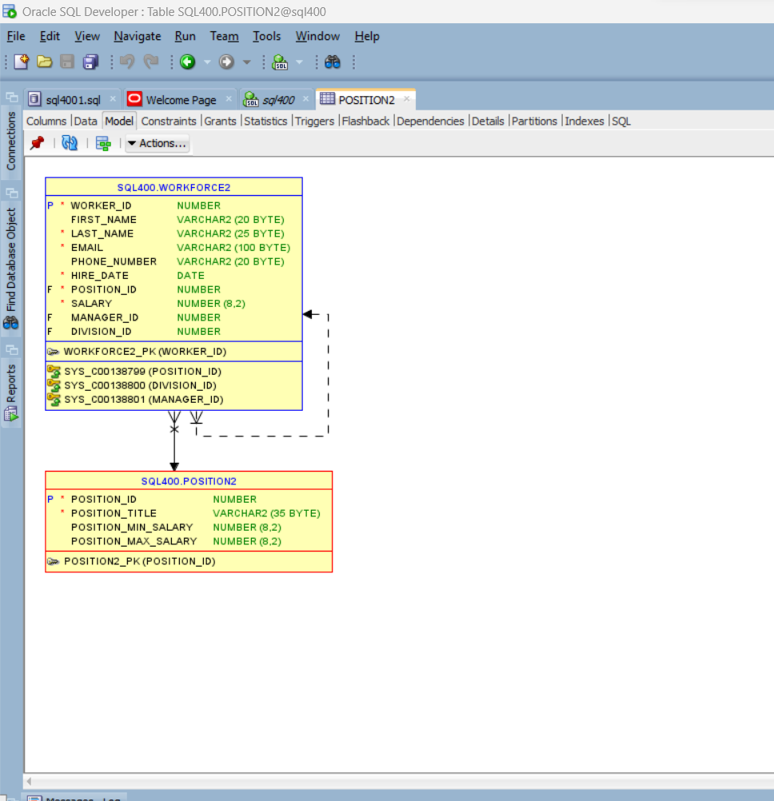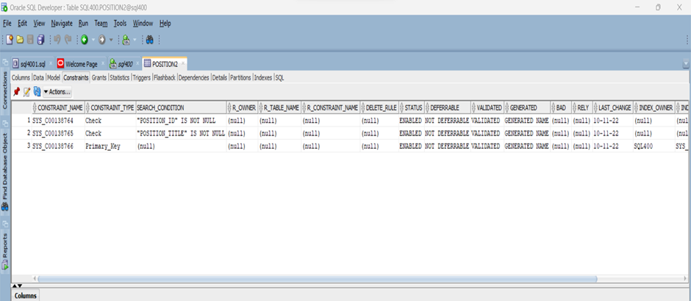

**Division2:**

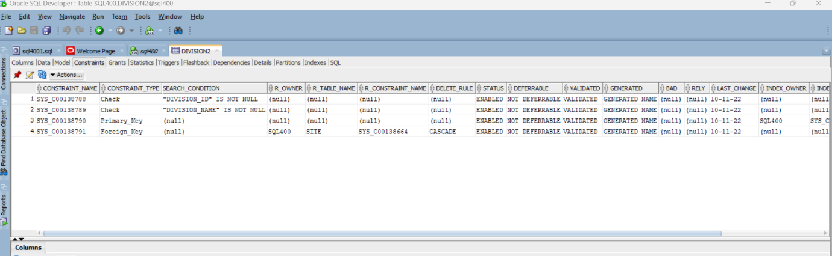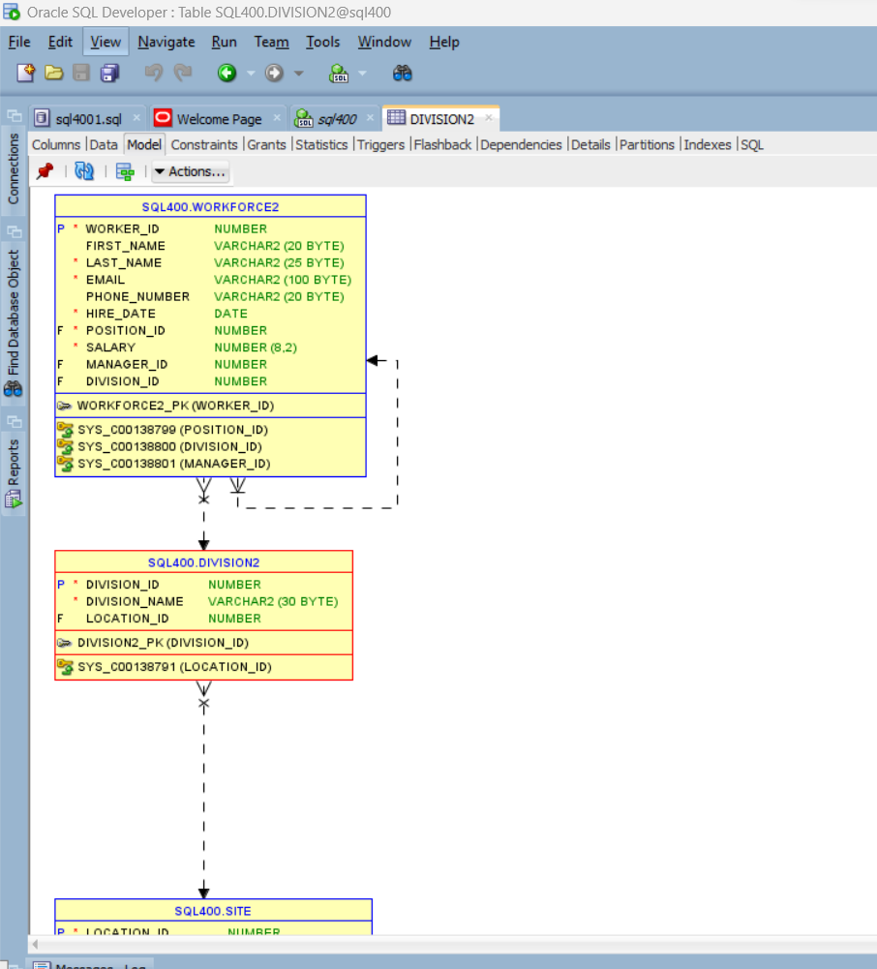

**QUERIES**

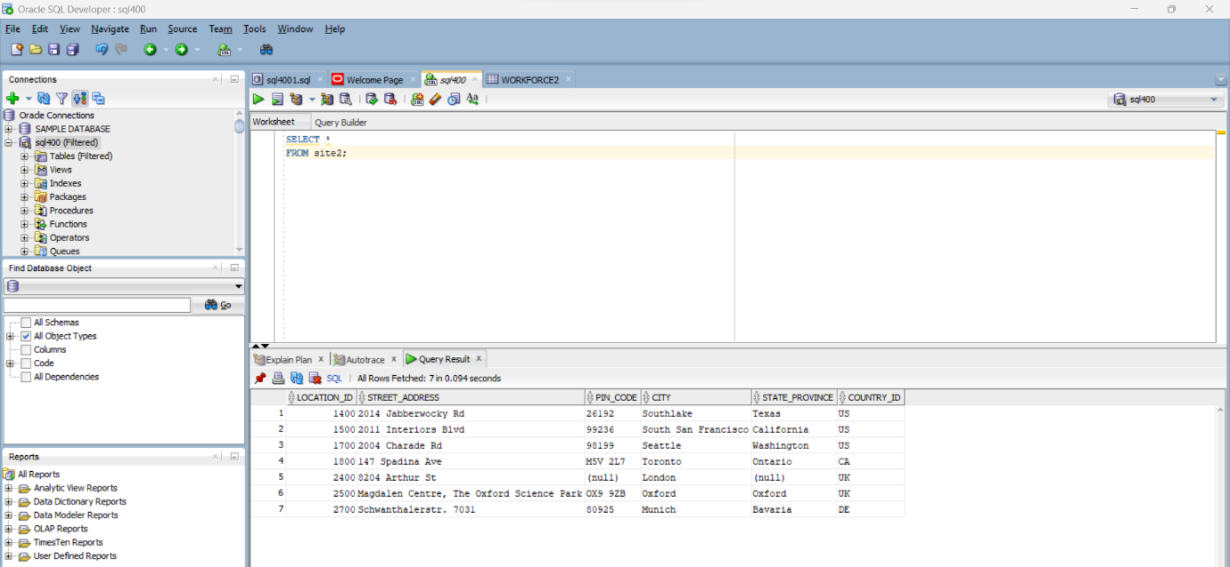

SELECT

division_id,

COUNT(*)

FROM

workforce2

GROUP BY

division_id;

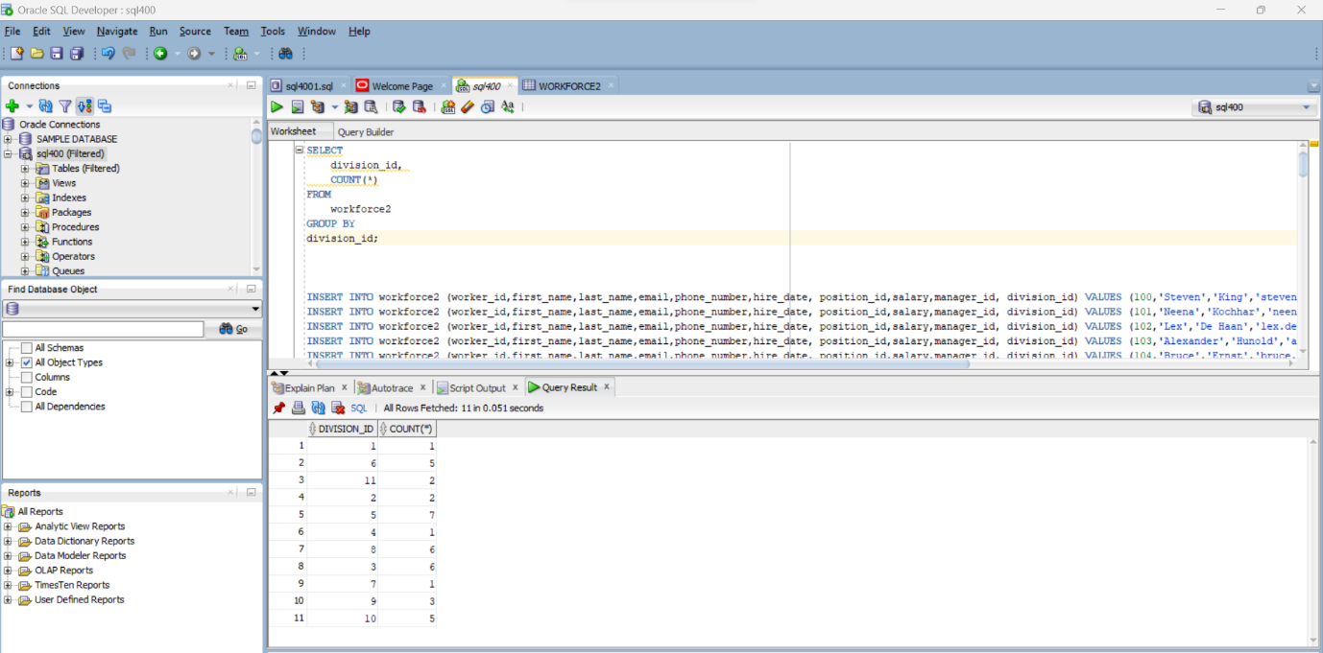

SELECT

first_name,

last_name

FROM

workforce2

UNION

SELECT

first_name,

last_name

FROM

nominee2

ORDER BY

last_name;

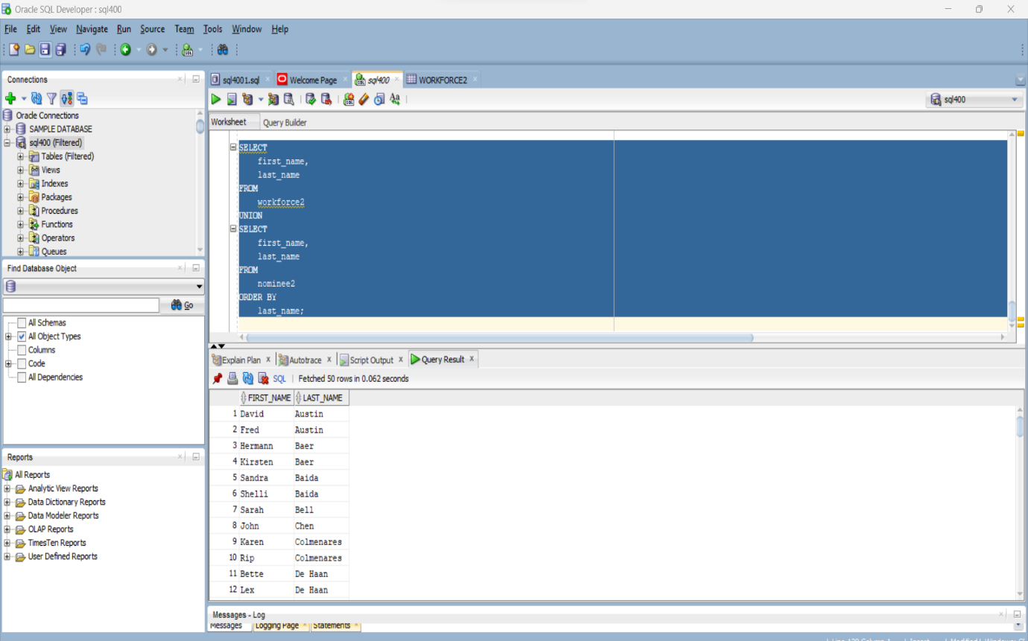

SELECT

division_name

FROM

division2 d

WHERE

EXISTS( SELECT

1

FROM

workforce2 e

WHERE

salary > 10000

AND e.division_id = d.division_id)

ORDER BY division_name;

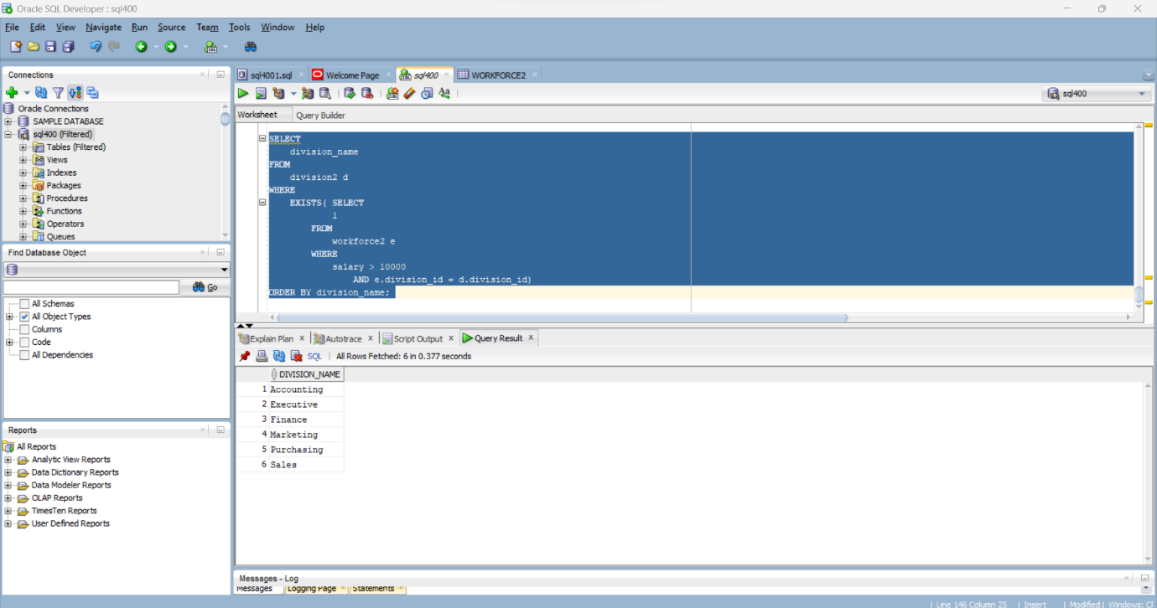

SELECT

worker_id,

first_name,

last_name,

hire_date,

salary

FROM

workforce2

ORDER BY

first_name,

last_name DESC;

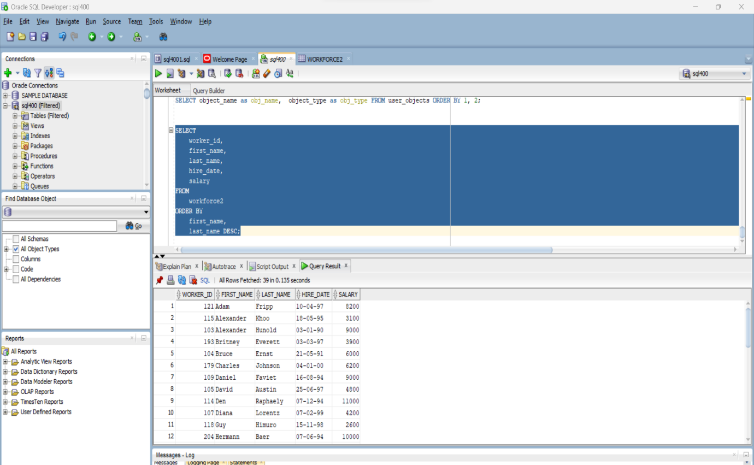

SELECT

e.division_id,

division_name,

COUNT(*)

FROM

workforce2 e

INNER JOIN division2 d

ON d.division_id = e.division_id

GROUP BY

e.division_id,

division_name;

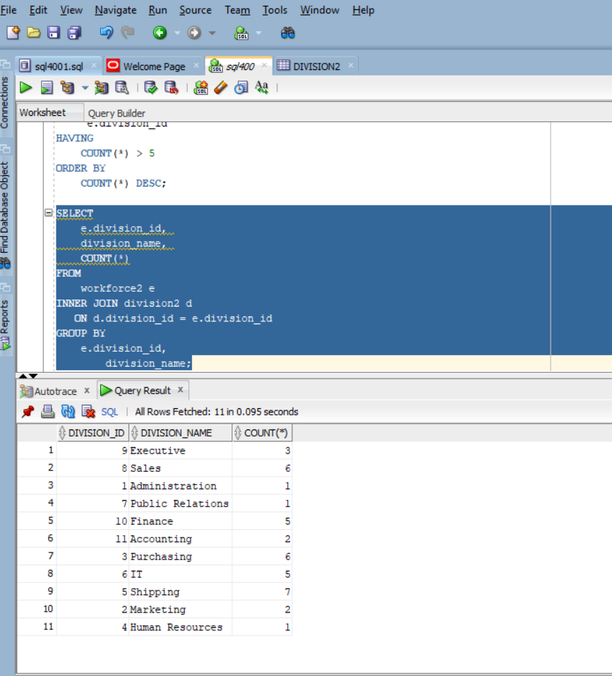

**Data Visualization**

The data was analyzed in R and Excel

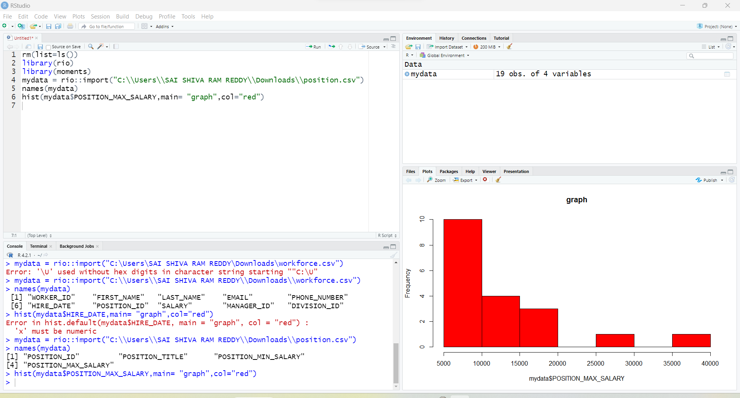

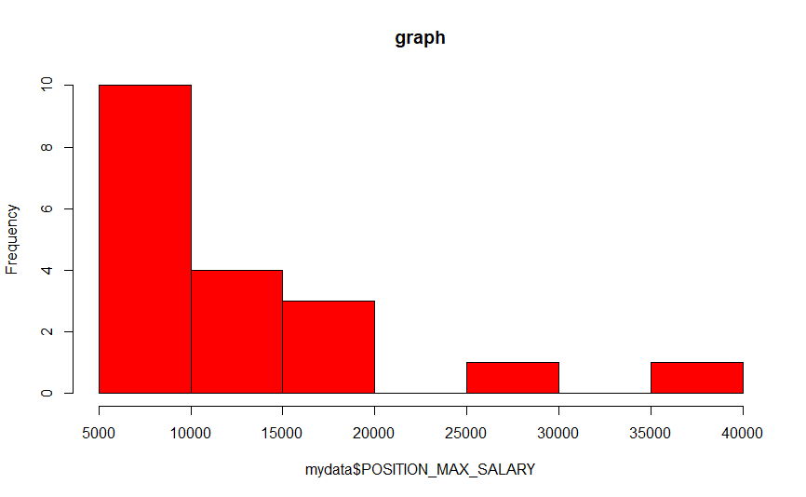

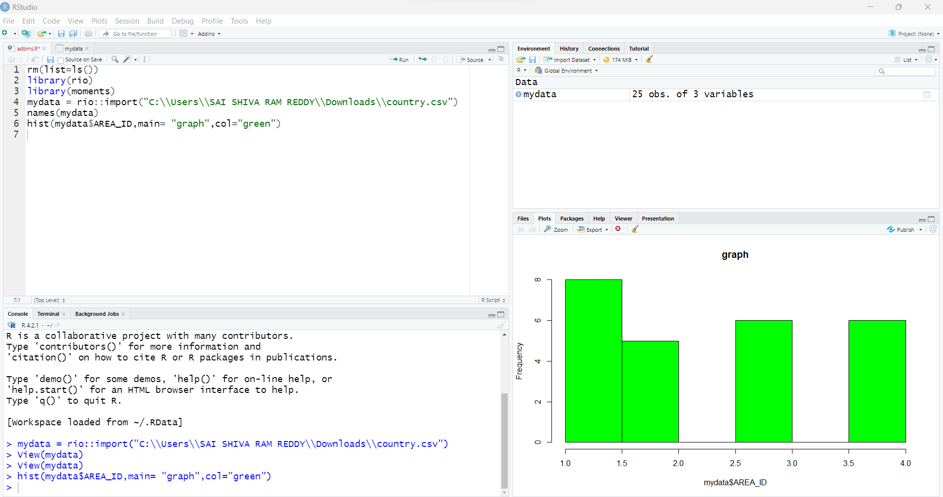

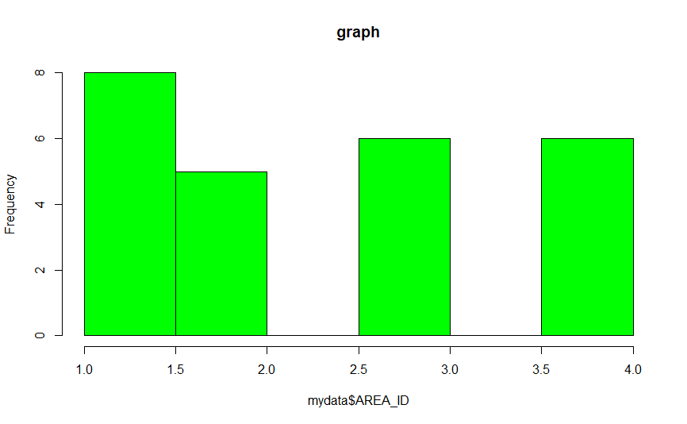

**Performance tuning and indexing:**

SELECT *

FROM workforce2 WHERE (last_name) = 'Everett';

Here we can observe both cardinality and cost of the result which increases by inputing the indexing

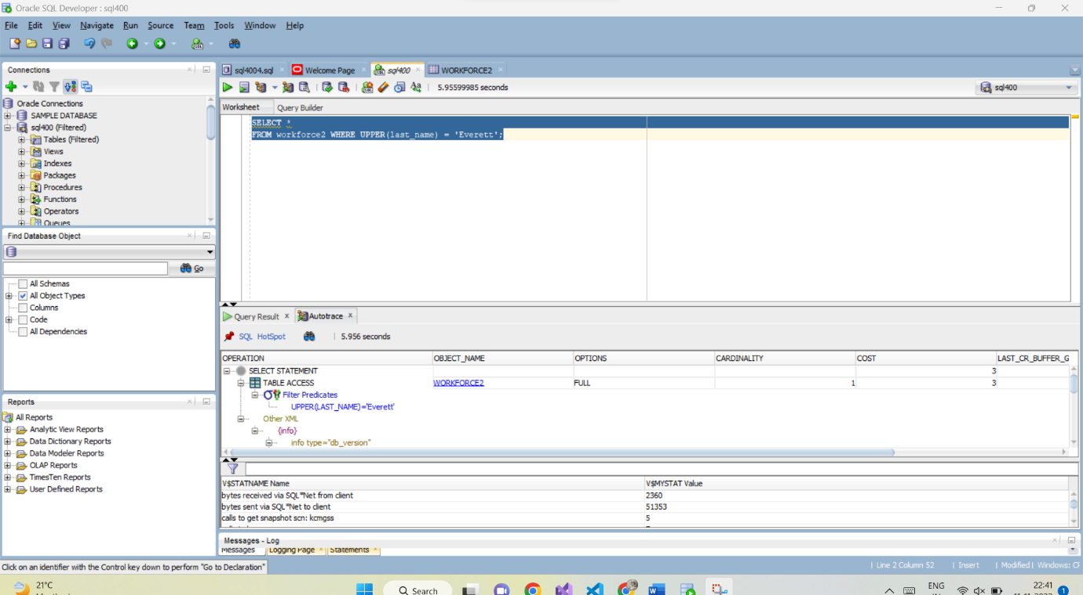

SELECT *

FROM workforce2 WHERE UPPER(last_name) = 'Everett';

Now observe the same by using the indexing

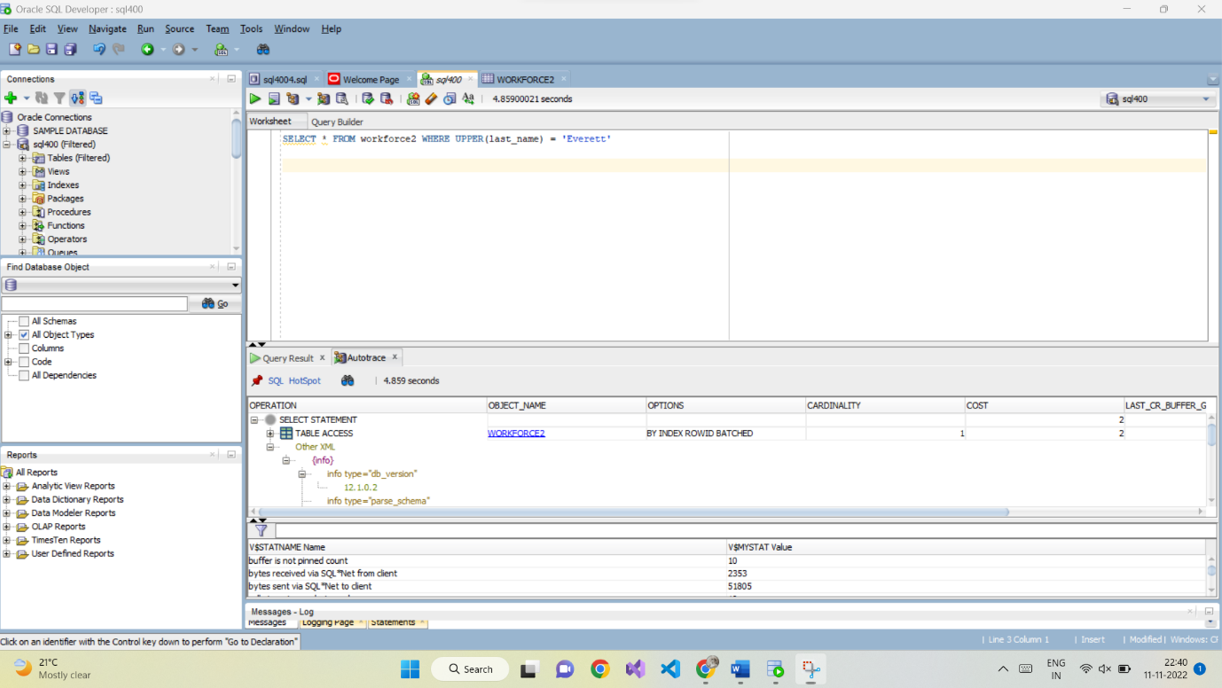

Here we can observe cost decreases and time also reduces

**DBA SCRIPTS**

1.

SELECT object_name as obj_name, object_type as obj_type FROM user_objects ORDER BY 1, 2;

**Description**: The above sql command accesses user_objects and displays object_name and object type for current user.

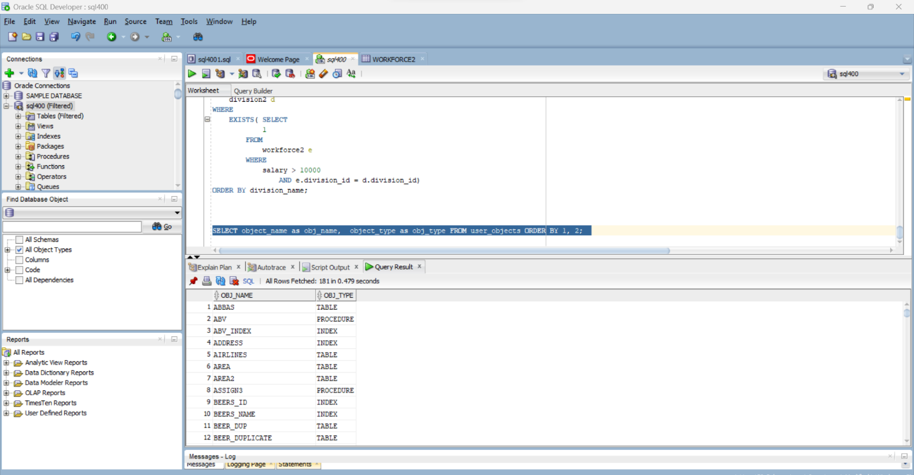

SET SERVEROUTPUT ON

SET VERIFY OFF

SELECT

a.granted_role, a.admin_option

FROM

user_role_privs a

ORDER BY a.granted_role;

SELECT

a.privilege,

a.admin_option

FROM user_sys_privs

ORDER BY a.privilege;

SET VERIFY ON

**DBA script…**

SELECT t.table_name,

c.constraint_name,

c.table_name workforce2,

worker_id.column name

FROM all_constraints t,

all constraints c,

all_cons_columns worker_id

WHERE c.I_constraint_name=t.constraint_name

AND OAND

c.table_name

acc.table_name

c.constraint_name

acc.constraint_name

AND NOT EXISTS (SELECT 1

FROM WHERE

all_ind_columns aid aid. table_name

- acc.table_name AND aid.column_name acc.column_name)

0RDER BY c.tabte_name:

SELECT

privilege, grantee, admin_option

FROM dba_sys_priva WHERE privilege LIKE UPPER (1) ORDER BY

privilege, grantee:

**creating the tables:**

CREATE TABLE area2 (

area_id NUMBER GENERATED BY DEFAULT AS IDENTITY PRIMARY KEY,

area_name VARCHAR2 (25) DEFAULT NULL

);

CREATE TABLE country2 (

country_id CHAR (2) PRIMARY KEY,

country_name VARCHAR2 (40) DEFAULT NULL,

area_id NUMBER NOT NULL,

FOREIGN KEY (area_id) REFERENCES area (area_id) ON DELETE CASCADE

);

CREATE TABLE site2 (

location_id NUMBER GENERATED BY DEFAULT AS IDENTITY PRIMARY KEY,

street_address VARCHAR2 (40) DEFAULT NULL,

pin_code VARCHAR2 (12) DEFAULT NULL,

city VARCHAR2 (30) NOT NULL,

state_province VARCHAR2 (25) DEFAULT NULL,

country_id CHAR (2) NOT NULL,

FOREIGN KEY (country_id) REFERENCES country (country_id) ON DELETE CASCADE

);

CREATE TABLE position2 (

position_id NUMBER GENERATED BY DEFAULT AS IDENTITY PRIMARY KEY,

position_title VARCHAR2 (35) NOT NULL,

position_min_salary NUMBER (8, 2) DEFAULT NULL,

position_max_salary NUMBER (8, 2) DEFAULT NULL

);

CREATE TABLE division2 (

division_id NUMBER GENERATED BY DEFAULT AS IDENTITY PRIMARY KEY,

division_name VARCHAR2 (30) NOT NULL,

location_id NUMBER DEFAULT NULL,

FOREIGN KEY (location_id) REFERENCES site (location_id) ON DELETE CASCADE

);

CREATE TABLE workforce2 (

worker_id NUMBER GENERATED BY DEFAULT AS IDENTITY PRIMARY KEY,

first_name VARCHAR2 (20) DEFAULT NULL,

last_name VARCHAR2 (25) NOT NULL,

email VARCHAR2 (100) NOT NULL,

phone_number VARCHAR2 (20) DEFAULT NULL,

hire_date DATE NOT NULL,

position_id NUMBER NOT NULL,

salary NUMBER (8, 2) NOT NULL,

manager_id NUMBER DEFAULT NULL,

division_id NUMBER DEFAULT NULL,

FOREIGN KEY (position_id) REFERENCES position (position_id) ON DELETE CASCADE,

FOREIGN KEY (division_id) REFERENCES division (division_id) ON DELETE CASCADE,

FOREIGN KEY (manager_id) REFERENCES workforce (worker_id)

);

CREATE TABLE nominee2 (

nominee_id NUMBER GENERATED BY DEFAULT AS IDENTITY PRIMARY KEY,

first_name VARCHAR2 (50) NOT NULL,

last_name VARCHAR2 (50) NOT NULL,

relation VARCHAR2 (25) NOT NULL,

worker_id NUMBER NOT NULL,

FOREIGN KEY (worker_id) REFERENCES workforce (worker_id) ON DELETE CASCADE

);